1. Navigate to folder where artefact repository is checked out in your local machine and run the command 🡪 ./run-sa.sh Reactive 1. This command is for running the self-adaptive script.

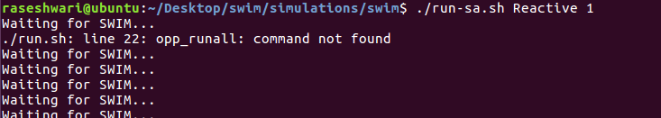

1. Navigate in a new terminal to the folder where the master swim repository is checked out on your local machine and run the command 🡪 
2. Once the command in step 2 is run go back to terminal opened in step 1. It will show message connected to swim as seen below.

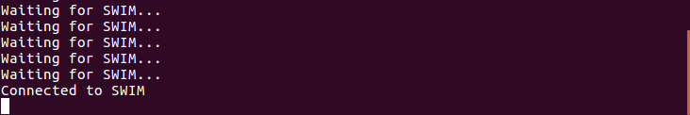

Note that until we run the command listed in step 2, ‘Waiting for SWIM’ will continue to display on the terminal.

1. Once connected to SWIM, following results can be seen on step 2 terminal.

